Lab 2: Containerization & Kubernetes Orchestration
Task 8: Configure continuous deployment

1. Objective
Automate deployment to Kubernetes by integrating the build with a CI/CD pipeline that applies the manifests.

2. Pipeline definition
The Jenkinsfile has 5 stages: build image, load to Minikube, apply manifests, deploy new image, verify rollout. cicd.ps1 runs the same stages from the command line.
pipeline {
agent any
stages {
stage('Build Image') { steps { bat 'docker build -t lab2-python-app:%BUILD_NUMBER% app' } }
stage('Load to Minikube') { steps { bat 'minikube image load lab2-python-app:%BUILD_NUMBER%' } }
stage('Apply Manifests') { steps { bat 'kubectl apply -f k8s/' } }
stage('Deploy New Image') { steps { bat 'kubectl set image deployment/lab2-app web=lab2-python-app:%BUILD_NUMBER%' } }
stage('Verify') { steps { bat 'kubectl rollout status deployment/lab2-app' } }
}
}

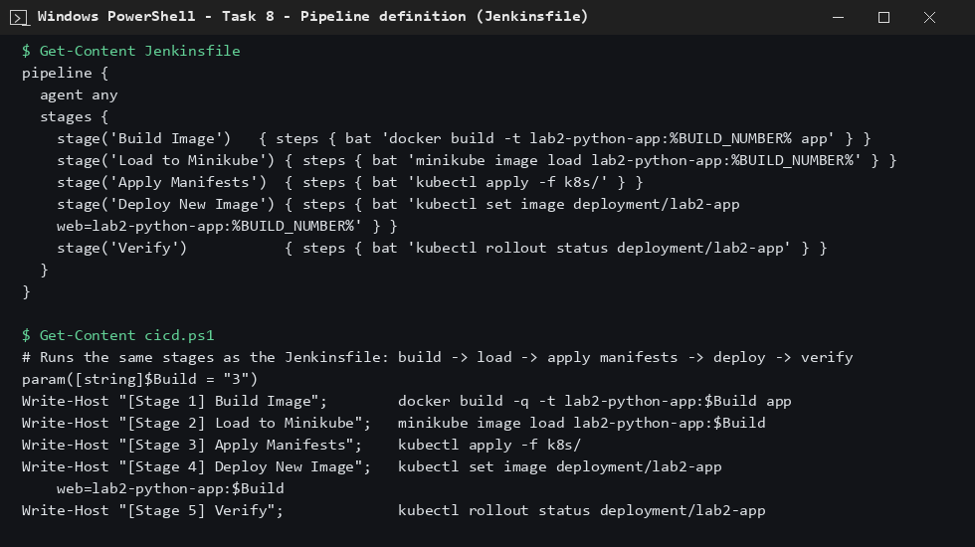
Figure 1: Jenkinsfile and the equivalent cicd.ps1 script

3. Pipeline run
powershell -File cicd.ps1 -Build 3

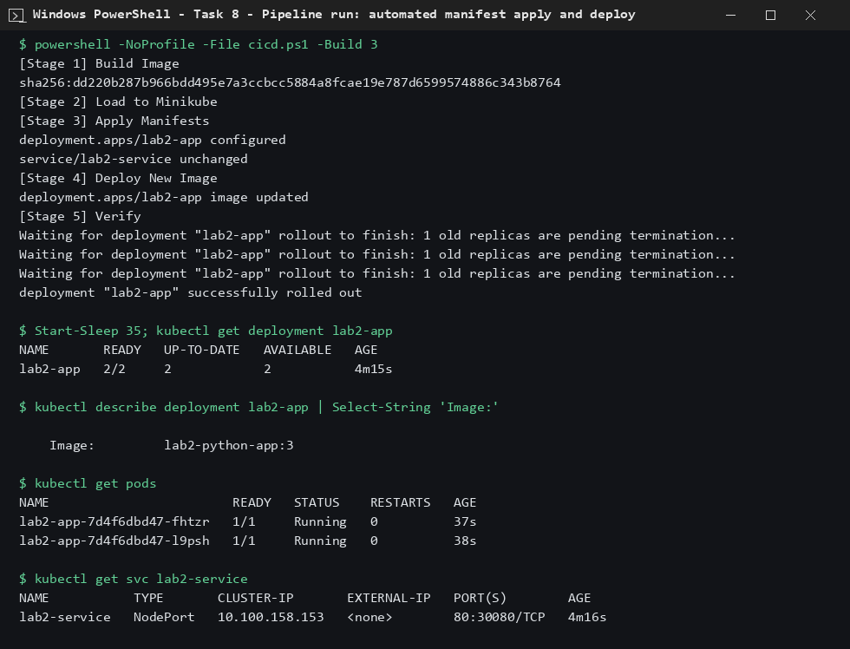
Figure 2: Pipeline run; deployment now runs image lab2-python-app:3

4. Note
The stages were executed with cicd.ps1 on the local machine. The Jenkinsfile contains the identical commands, so a Jenkins job pointed at this folder would perform the same deployment on every build.

5. Conclusion
A single pipeline run builds the image, applies the Kubernetes manifests and rolls out the new version automatically.

